**How to add Azure Mobile App to an UWP App**

In this step by step to Create Azure Mobile App using Azure Portal and Insert data from Universal Windows Platform App. Mobile Apps comes under Azure App Service. Azure App Service is a fully managed [Platform as a Service](https://azure.microsoft.com/overview/what-is-paas/) (PaaS) offering for professional developers that brings a rich set of capabilities to web, mobile and integration scenarios. Mobile Apps offers a highly scalable, globally available mobile application development platform for Enterprise Developers and System Integrators that brings a rich set of capabilities to mobile developers. Mobile App features:

* **Build native and cross platform apps -**
  + Building native Windows, iOS, Android apps
  + Cross platform Xamarin or Cordova
* **Connect to your enterprise systems** – with the help of this feature you can add corporate sign on option to connect with on-premises or cloud resources. Azure Active Directory available for identity providers for enterprise Authentication. Also Social providers such as Facebook, Twitter and Microsoft account.
* **Build offline-ready apps with data sync** – Develop app using this feature to save data offline as well as sync data with the cloud to get latest data or records in the background when connectivity available. This Service allowing you to easily integrate with other NoSQL and SQL data providers, including Azure Table Storage, MongoDB, DocumentDB and SaaS API providers like Office 365 and Salesforce.com
* **Push Notifications to millions in seconds** - engage your customers with instant push notifications on any device, personalized to their needs, sent when the time is right.

# Prerequisites

Microsoft Azure Subscription (MSDN subscribers or [sign up for one month free trial](https://azure.microsoft.com/en-us/free/))

Visual Studio 2015 with UWP SDK – For Download [Click here](https://www.visualstudio.com/en-us/downloads/download-visual-studio-vs.aspx)

.NET Azure SDK for Visual Studio 2015 – For Download  [Click here](https://azure.microsoft.com/en-us/downloads/?sdk=net)

# You will learn

* How to Create Azure Mobile App
* How to Create Database & Server
* How to Develop UWP App
* Add Mobile App to Existing UWP App

# Create Azure Mobile App

**Step 1:** Navigate to [Azure Portal](https://portal.azure.com/) & Sign in with Azure Credentials.  
  
**Step 2:** Click on New button -> Web + Mobile -> Mobile App

[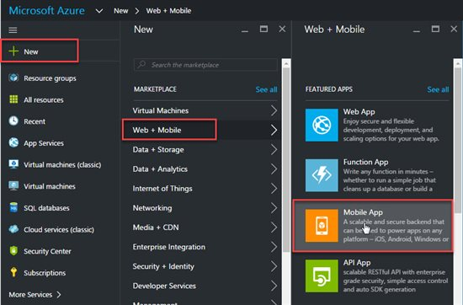](http://social.technet.microsoft.com/wiki/cfs-file.ashx/__key/communityserver-wikis-components-files/00-00-00-00-05/2514.AMAUWP01.jpg)

**Step 3:** Enter Mobile App Name, Choose Azure Subscription, Create new or use existing Resource Group.  
  
[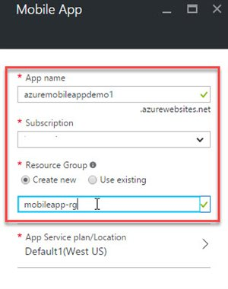](http://social.technet.microsoft.com/wiki/cfs-file.ashx/__key/communityserver-wikis-components-files/00-00-00-00-05/6663.AMAUWP02.jpg)  
  
Click on App Service Plan/Location -> Create New  
  
[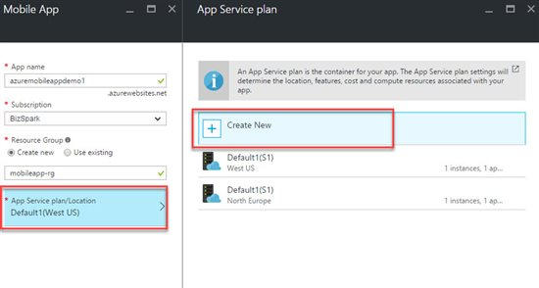](http://social.technet.microsoft.com/wiki/cfs-file.ashx/__key/communityserver-wikis-components-files/00-00-00-00-05/8561.AMAUWP03.jpg)  
  
Enter App Service Plan name, Location, Pricing tier  
  
[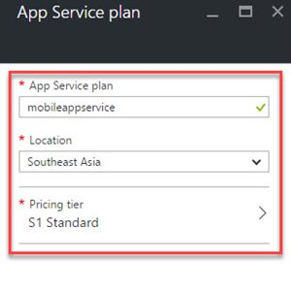](http://social.technet.microsoft.com/wiki/cfs-file.ashx/__key/communityserver-wikis-components-files/00-00-00-00-05/1488.AMAUWP04.jpg)  
[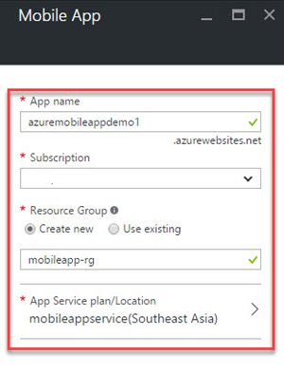](http://social.technet.microsoft.com/wiki/cfs-file.ashx/__key/communityserver-wikis-components-files/00-00-00-00-05/1323.AMAUWP05.jpg)  
  
**Step 4:** Mobile App created successfully, Click on “**Easy tables**” inside Mobile section. Click on Easy Table Configuration option.  
  
[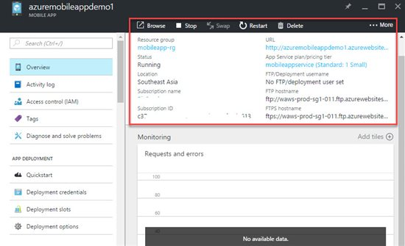](http://social.technet.microsoft.com/wiki/cfs-file.ashx/__key/communityserver-wikis-components-files/00-00-00-00-05/5047.AMAUWP06.jpg)  
  
[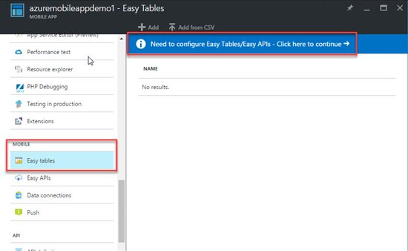](http://social.technet.microsoft.com/wiki/cfs-file.ashx/__key/communityserver-wikis-components-files/00-00-00-00-05/6811.AMAUWP07.jpg)  
  
  
**Step 5:** First select “**Connect to database**“ option. Add new data connection by clicking on “**Add**” button.   
  
[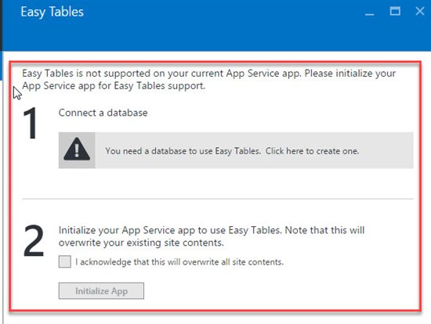](http://social.technet.microsoft.com/wiki/cfs-file.ashx/__key/communityserver-wikis-components-files/00-00-00-00-05/4118.AMAUWP08.jpg)  
  
[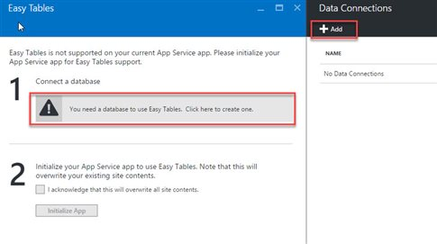](http://social.technet.microsoft.com/wiki/cfs-file.ashx/__key/communityserver-wikis-components-files/00-00-00-00-05/0045.AMAUWP09.jpg)

**Step 6:** Choose Type of Database: SQL Database or Storage. Click on SQL Database & create a new database.

[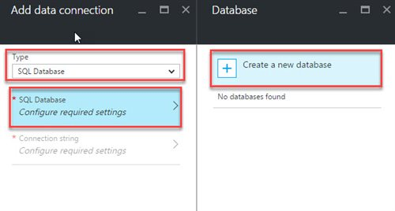](http://social.technet.microsoft.com/wiki/cfs-file.ashx/__key/communityserver-wikis-components-files/00-00-00-00-05/7180.AMAUWP10.jpg)

**Step 7**: Enter Database name, Pricing Tier, Target Server, Collation. No server created as of now so please select Target server & create a new Server. Enter Server name, admin login, password, location.  
  
[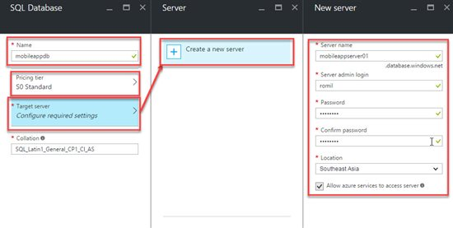](http://social.technet.microsoft.com/wiki/cfs-file.ashx/__key/communityserver-wikis-components-files/00-00-00-00-05/5611.AMAUWP11.jpg)  
  
**Step 8:** Select last option of database “**Connection string**” option. Just check all data filled is correct or not.  
  
[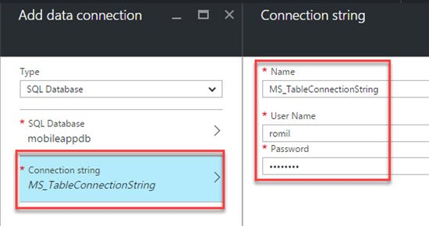](http://social.technet.microsoft.com/wiki/cfs-file.ashx/__key/communityserver-wikis-components-files/00-00-00-00-05/5531.AMAUWP12.jpg)

Wait for few second database & server is creating

[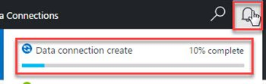](http://social.technet.microsoft.com/wiki/cfs-file.ashx/__key/communityserver-wikis-components-files/00-00-00-00-05/0878.AMAUWP13.jpg)

**Step 9:** Database & Server created in Easy Tables. Now check on “**I acknowledge that this will overwrite all site contents**” & click on **“Initialize App**” button.  
  
[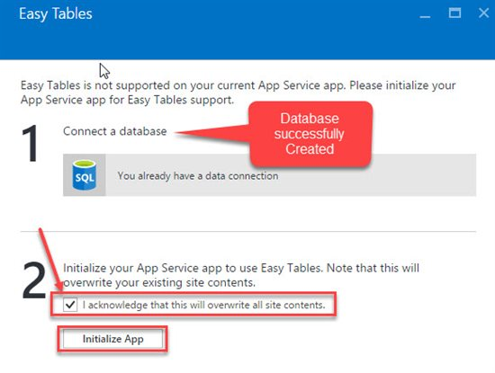](http://social.technet.microsoft.com/wiki/cfs-file.ashx/__key/communityserver-wikis-components-files/00-00-00-00-05/3223.AMAUWP14.jpg)  
  
  
**Step 10:** Click on Add button to create table in database  
  
[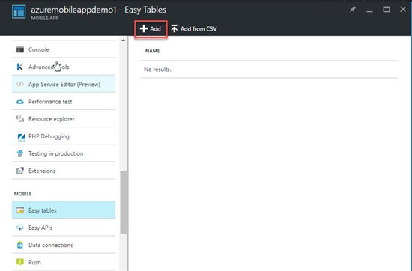](http://social.technet.microsoft.com/wiki/cfs-file.ashx/__key/communityserver-wikis-components-files/00-00-00-00-05/2806.AMAUWP15.jpg)  
  
**Step 11:** Enter table name & all permissions: Insert, Update, Delete, Read, Undelete.  
  
[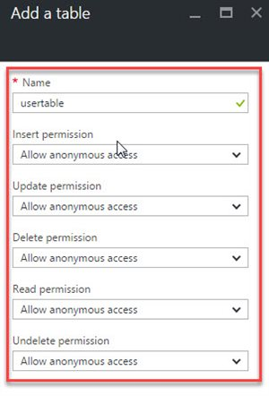](http://social.technet.microsoft.com/wiki/cfs-file.ashx/__key/communityserver-wikis-components-files/00-00-00-00-05/7266.AMAUWP16.jpg)

For this example we are considering “**Allow anonymous access**”.

**Step 12:** Click on Table Name  
  
[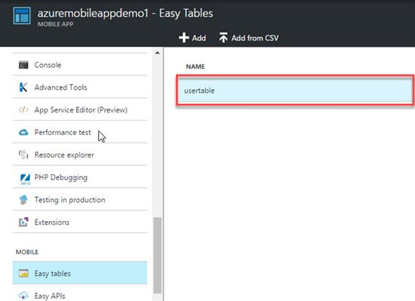](http://social.technet.microsoft.com/wiki/cfs-file.ashx/__key/communityserver-wikis-components-files/00-00-00-00-05/6675.AMAUWP17.jpg)  
  
Next step is to create columns or fields in table so click on “**Manage Schema**”  
  
[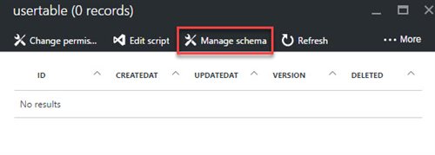](http://social.technet.microsoft.com/wiki/cfs-file.ashx/__key/communityserver-wikis-components-files/00-00-00-00-05/3716.AMAUWP18.jpg)

**Step 13**: Add a columns

-         Column name : firstname , Type : String

-         Column name : lastname , Type : String

-         Column name : city , Type : String

[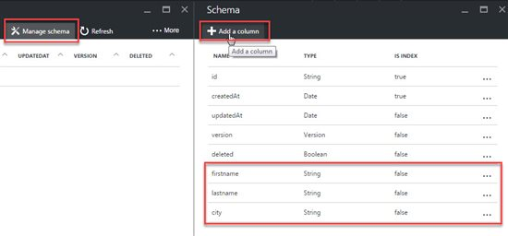](http://social.technet.microsoft.com/wiki/cfs-file.ashx/__key/communityserver-wikis-components-files/00-00-00-00-05/4214.AMAUWP19.jpg)

# Create UWP App

**Step 14:** Start Visual Studio 2015 & Create New Project.   
  
[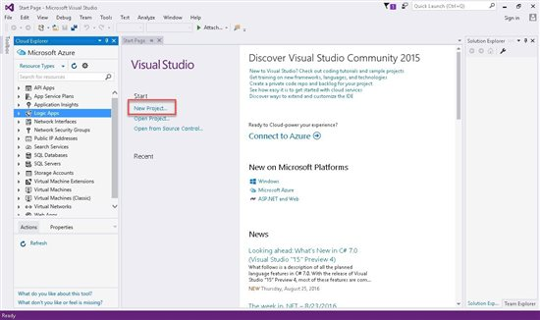](http://social.technet.microsoft.com/wiki/cfs-file.ashx/__key/communityserver-wikis-components-files/00-00-00-00-05/5141.AMAUWP20.jpg)

**Step 15:** First select Universal templates & then select Blank App (Universal Windows)  
  
[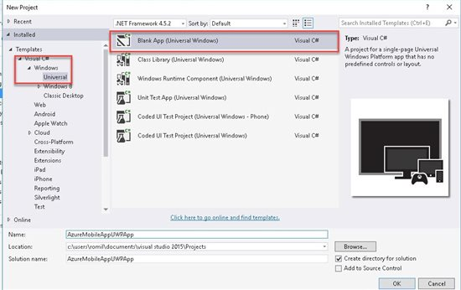](http://social.technet.microsoft.com/wiki/cfs-file.ashx/__key/communityserver-wikis-components-files/00-00-00-00-05/0825.AMAUWP21.jpg)

**Note:** if Windows Universal Platform SDK not installed then this options will not available. So please check when Visual Studio installation going on.

Select Target Version of UWP Project

[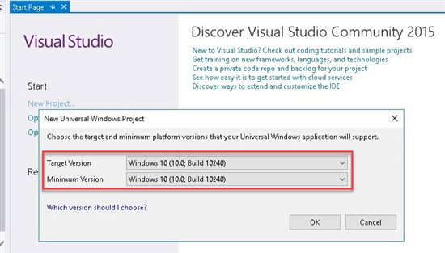](http://social.technet.microsoft.com/wiki/cfs-file.ashx/__key/communityserver-wikis-components-files/00-00-00-00-05/6013.AMAUWP22.jpg)

**Step 16:** To Deploy or run an UWP App it’s require Developer Mode enable. So please follow below step to enable.

[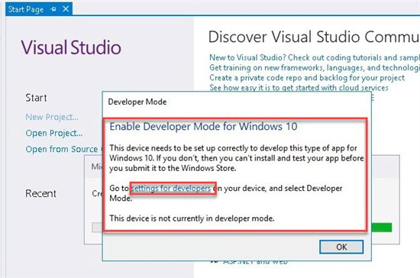](http://social.technet.microsoft.com/wiki/cfs-file.ashx/__key/communityserver-wikis-components-files/00-00-00-00-05/7484.AMAUWP23.jpg)   
  
[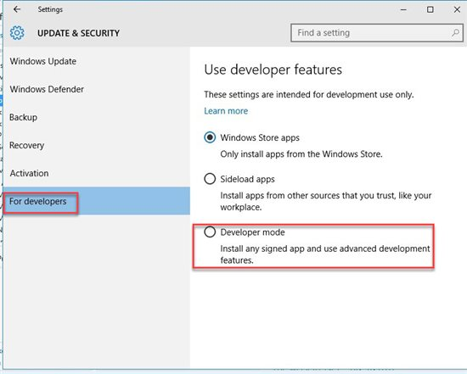](http://social.technet.microsoft.com/wiki/cfs-file.ashx/__key/communityserver-wikis-components-files/00-00-00-00-05/6648.AMAUWP24.jpg)  
  
[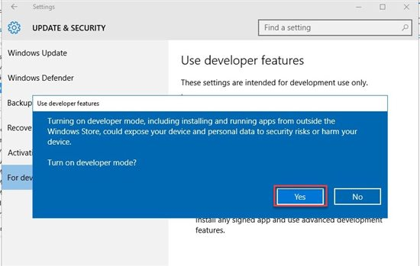](http://social.technet.microsoft.com/wiki/cfs-file.ashx/__key/communityserver-wikis-components-files/00-00-00-00-05/8081.AMAUWP25.jpg)

Now UWP app is ready to add Azure Mobile app

[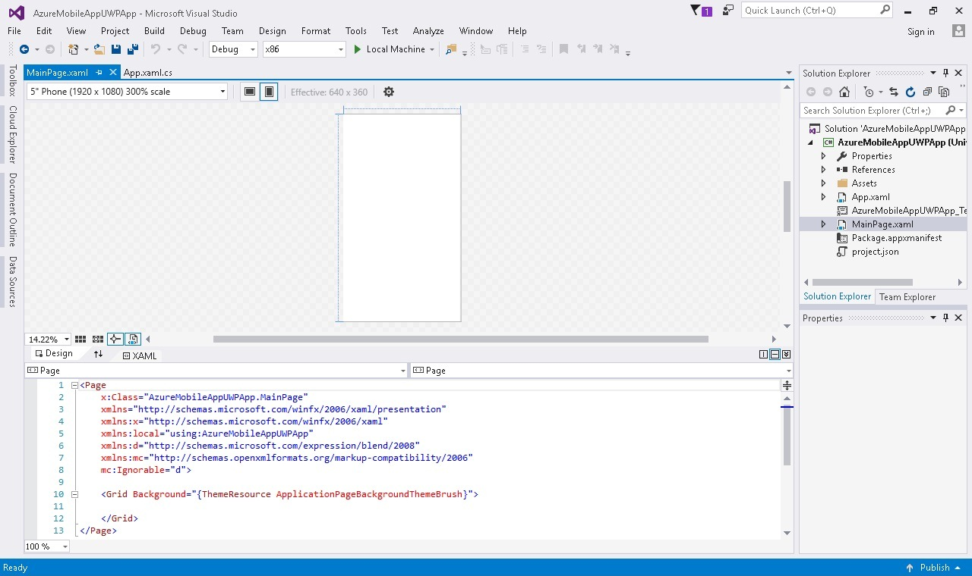](http://social.technet.microsoft.com/wiki/cfs-file.ashx/__key/communityserver-wikis-components-files/00-00-00-00-05/4064.AMAUWP26.jpg)

**Step 17**: Open MainPage.xaml file & add below code for app designing or UI part.

[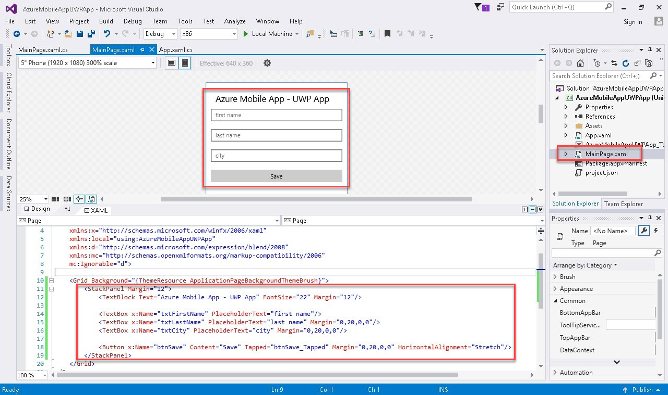](http://social.technet.microsoft.com/wiki/cfs-file.ashx/__key/communityserver-wikis-components-files/00-00-00-00-05/8664.AMAUWP27.jpg)

**<StackPanel Margin="12">**

**<TextBlock Text="Azure Mobile App - UWP App" FontSize="22" Margin="12"/>**

**<TextBox x:Name="txtFirstName" PlaceholderText="first name"/>**

**<TextBox x:Name="txtLastName" PlaceholderText="last name" Margin="0,20,0,0"/>**

**<TextBox x:Name="txtCity" PlaceholderText="city" Margin="0,20,0,0"/>**

**<Button x:Name="btnSave" Content="Save" Tapped="btnSave_Tapped" Margin="0,20,0,0"HorizontalAlignment="Stretch"/>**

**</StackPanel>**

**Step 18**: Right Click on Project Name & select “**Manage NuGet Packages…**”  
  
[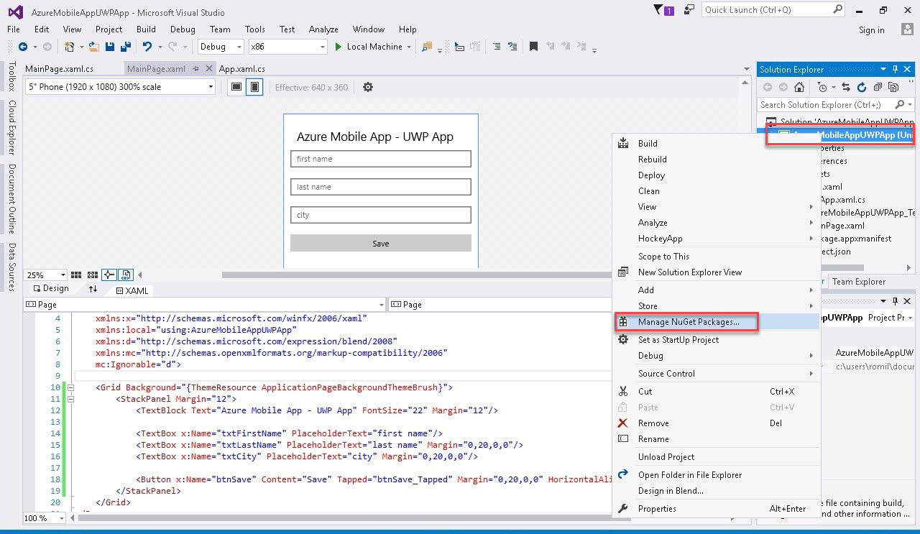](http://social.technet.microsoft.com/wiki/cfs-file.ashx/__key/communityserver-wikis-components-files/00-00-00-00-05/6116.AMAUWP28.jpg)

Select “**Browse**” tab. Search for “**Azure Mobile Client**” & install the packages.

[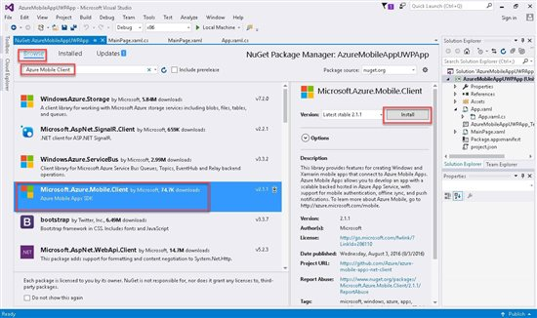](http://social.technet.microsoft.com/wiki/cfs-file.ashx/__key/communityserver-wikis-components-files/00-00-00-00-05/0602.AMAUWP29.jpg)   
  
[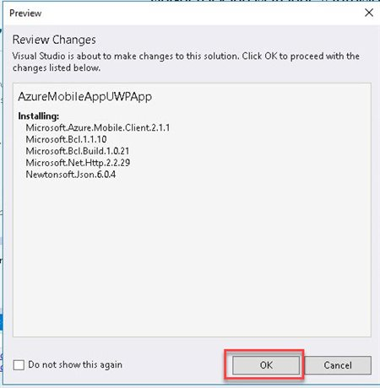](http://social.technet.microsoft.com/wiki/cfs-file.ashx/__key/communityserver-wikis-components-files/00-00-00-00-05/0068.AMAUWP30.jpg)  
  
[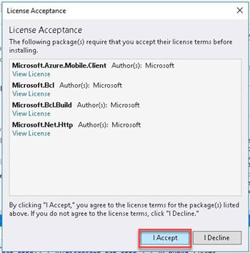](http://social.technet.microsoft.com/wiki/cfs-file.ashx/__key/communityserver-wikis-components-files/00-00-00-00-05/0815.AMAUWP31.jpg)

Step 19: After adding Azure Mobile App NuGet Packages, open App.xaml.cs

[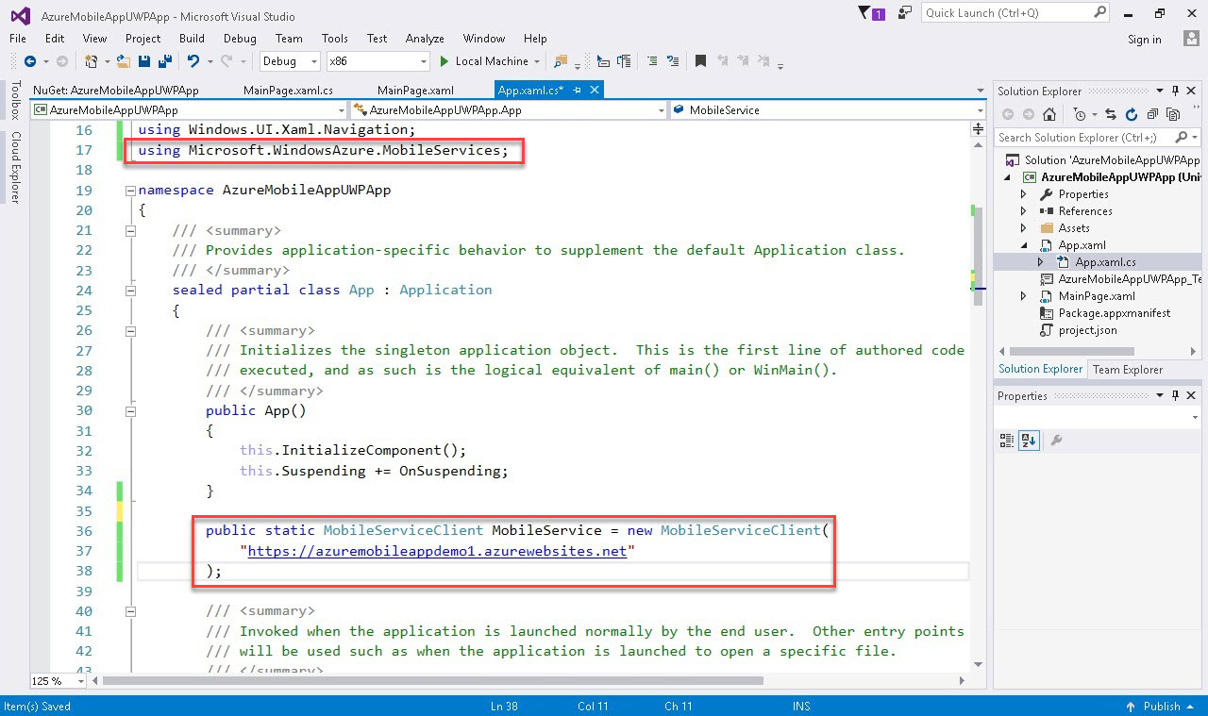](http://social.technet.microsoft.com/wiki/cfs-file.ashx/__key/communityserver-wikis-components-files/00-00-00-00-05/7457.AMAUWP32.jpg)  
  
Add reference:

using Microsoft.WindowsAzure.MobileServices;

Also add MobileServiceClient

//Please change Mobile App name

**public** **static** MobileServiceClient MobileService = **new** MobileServiceClient(

            "https://<azuremobileappname>.azurewebsites.net"

        );

**Step 20:** Again Right click on Project Name & Add new class. Please mention same name of class as given to table name on Azure.

[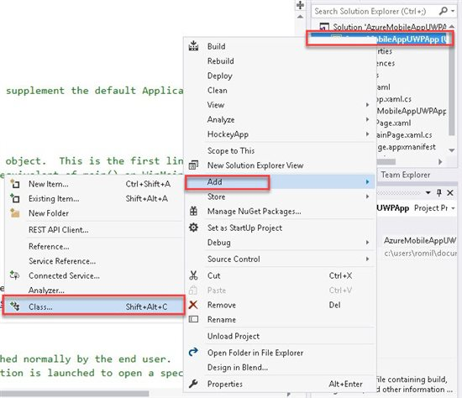](http://social.technet.microsoft.com/wiki/cfs-file.ashx/__key/communityserver-wikis-components-files/00-00-00-00-05/2772.AMAUWP33.jpg)  
  
[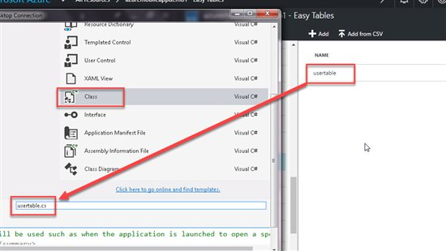](http://social.technet.microsoft.com/wiki/cfs-file.ashx/__key/communityserver-wikis-components-files/00-00-00-00-05/4520.AMAUWP34.jpg)  
  
[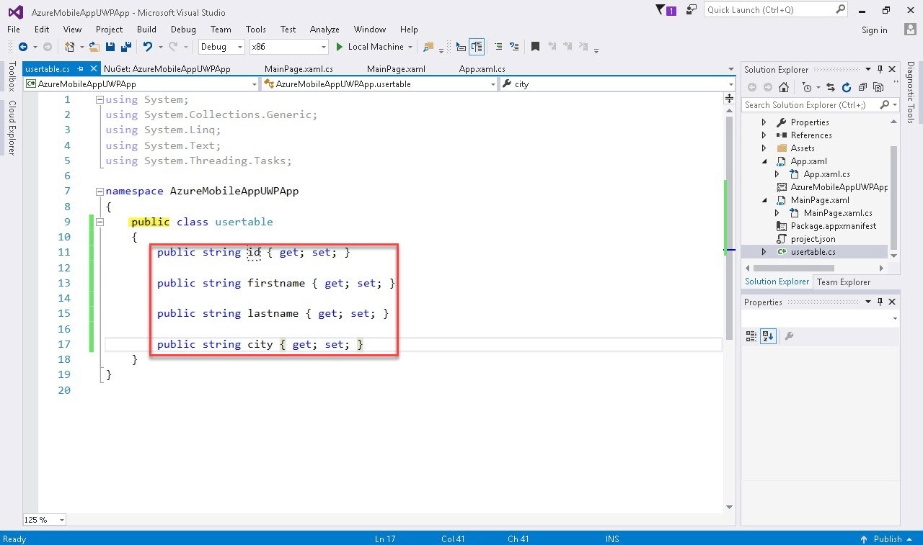](http://social.technet.microsoft.com/wiki/cfs-file.ashx/__key/communityserver-wikis-components-files/00-00-00-00-05/3326.AMAUWP35.jpg)

**public** **class** usertable

    {

**public** **string** id { **get**; **set**; }

**public** **string** firstname { **get**; **set**; }

**public** **string** lastname { **get**; **set**; }

**public** **string** city { **get**; **set**; }

    }

**Step 21**: Open MainPage.xaml.cs file

[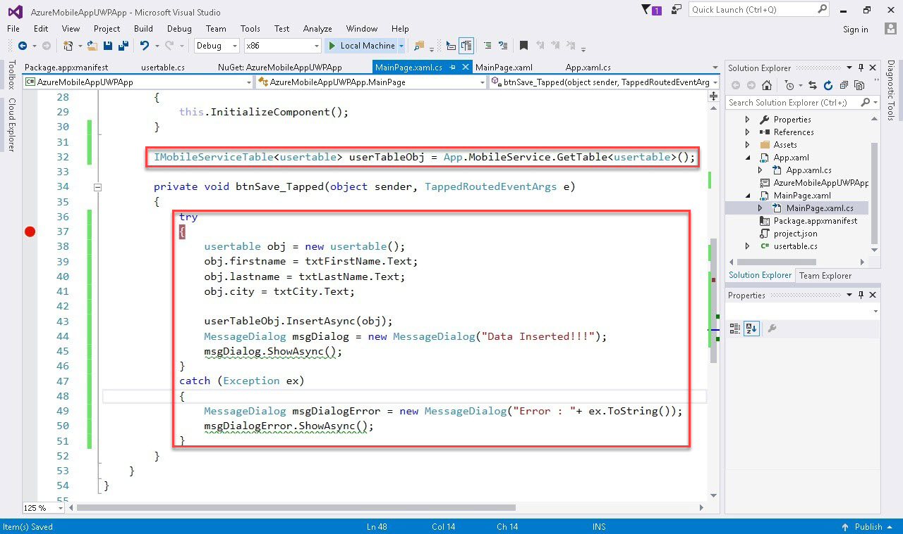](http://social.technet.microsoft.com/wiki/cfs-file.ashx/__key/communityserver-wikis-components-files/00-00-00-00-05/2843.AMAUWP36.jpg)  
  
Add references:

**using** Microsoft.WindowsAzure.MobileServices;

**using** Windows.UI.Popups;

IMobileServiceTable<usertable> userTableObj = App.MobileService.GetTable<usertable>();

**private** **void** btnSave_Tapped(**object** sender, TappedRoutedEventArgs e)

        {

**try**

            {

                usertable obj = **new** usertable();

                obj.firstname = txtFirstName.Text;

                obj.lastname = txtLastName.Text;

                obj.city = txtCity.Text;

                userTableObj.InsertAsync(obj);

                MessageDialog msgDialog = **new** MessageDialog("Data Inserted!!!");

                msgDialog.ShowAsync();

            }

**catch** (Exception ex)

            {

                MessageDialog msgDialogError = **new** MessageDialog("Error : "+ ex.ToString());

                msgDialogError.ShowAsync();

            }

        }

**Step 22**: Now run the app.

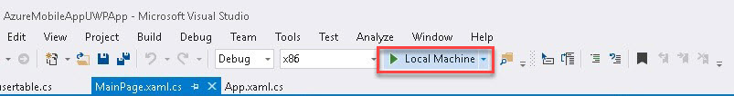  
  
[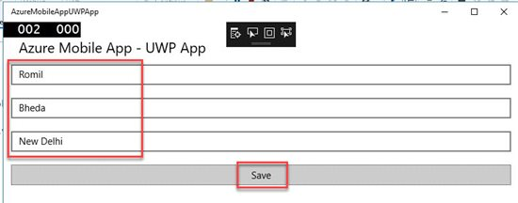](http://social.technet.microsoft.com/wiki/cfs-file.ashx/__key/communityserver-wikis-components-files/00-00-00-00-05/5658.AMAUWP37.jpg)  
  
[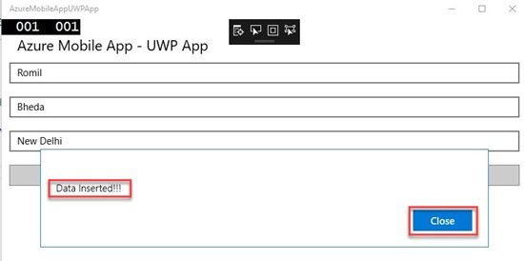](http://social.technet.microsoft.com/wiki/cfs-file.ashx/__key/communityserver-wikis-components-files/00-00-00-00-05/8664.AMAUWP38.jpg)  
  
  
Navigate to Mobile App's Easy Tables on Azure  
  
[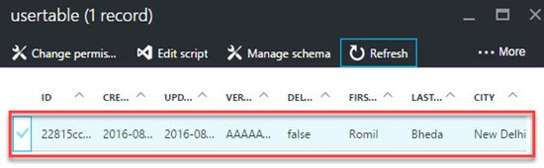](http://social.technet.microsoft.com/wiki/cfs-file.ashx/__key/communityserver-wikis-components-files/00-00-00-00-05/2161.AMAUWP39.jpg)

Congratulations from UWP app data successfully saved on Azure using Mobile App.